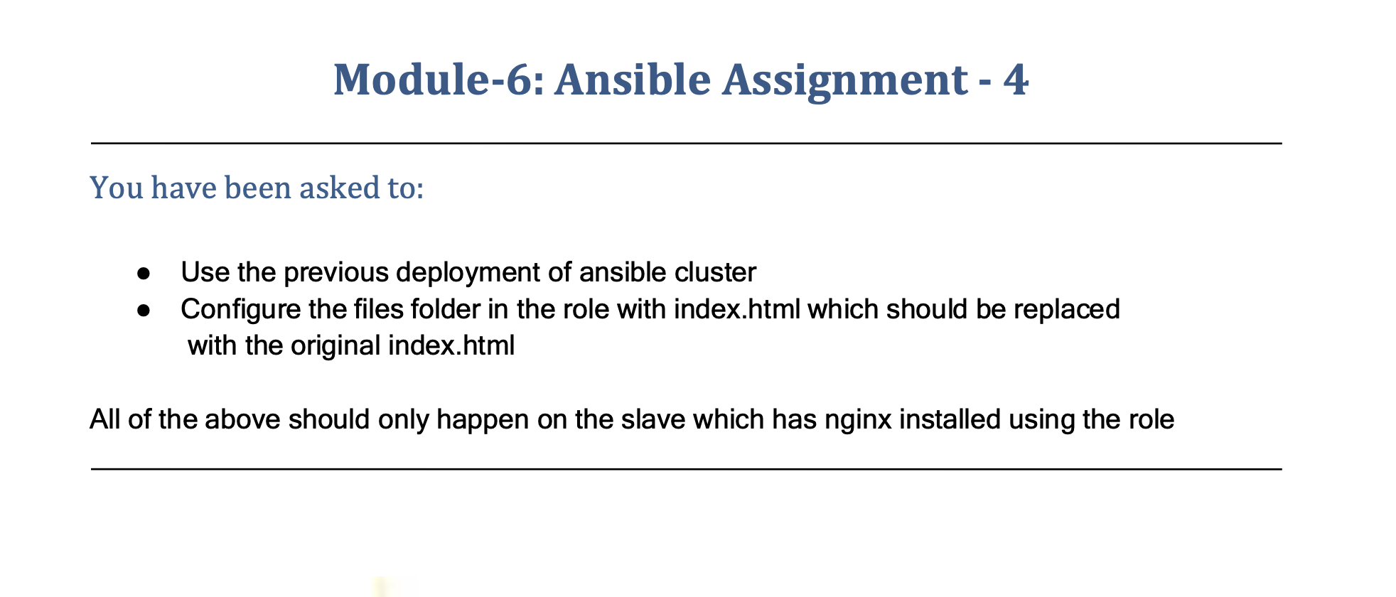

You have been asked to:

● Use the previous deployment of ansible cluster

● Configure the files folder in the role with index.html which should be replaced

with the original index.html

All of the above should only happen on the slave which has nginx installed using the role

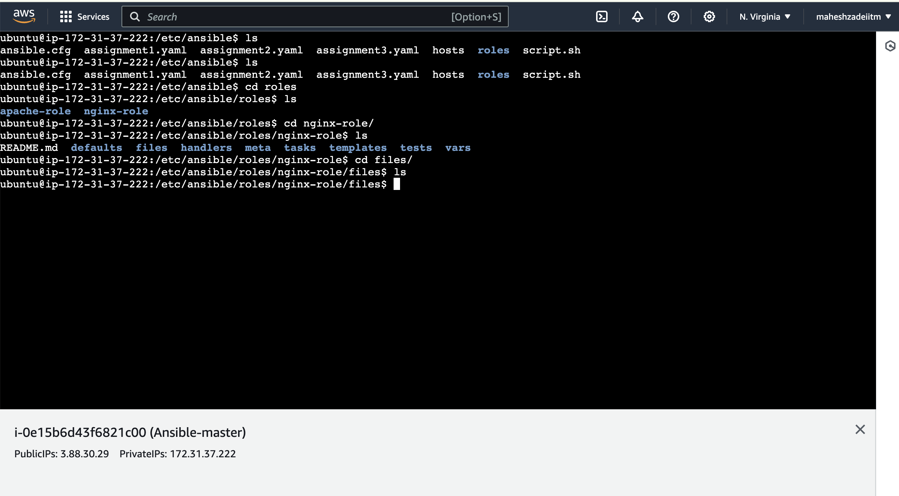

Go to file folder in nginx role

Sudo nano index.html

Write your code or your Name

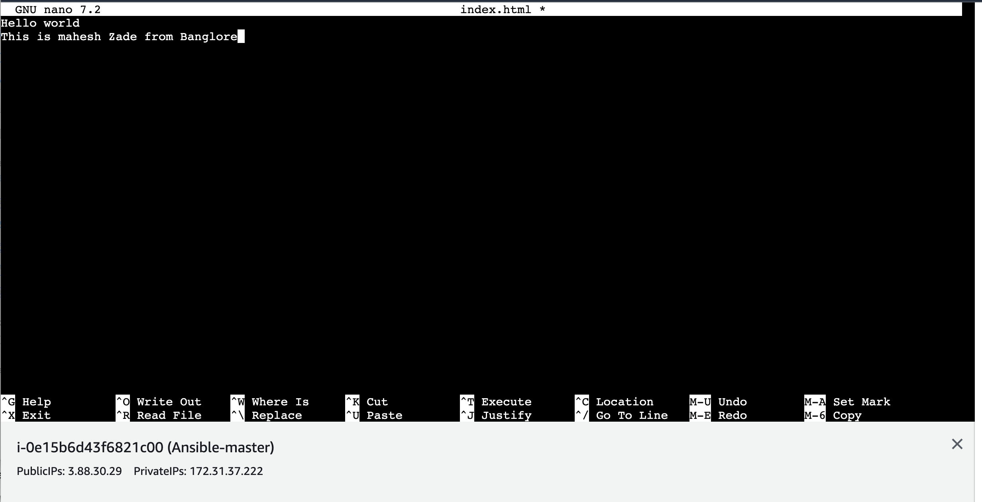

Save it

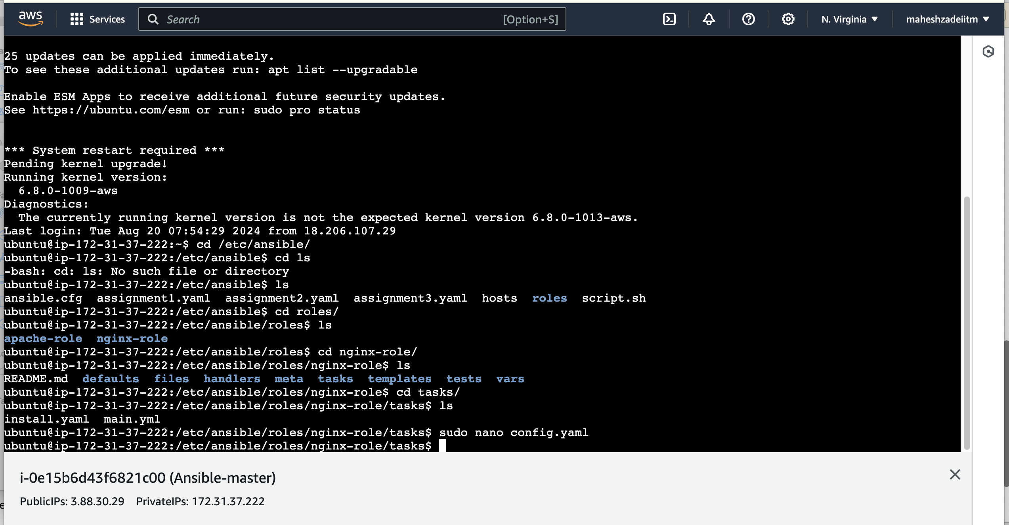

Run the command

sudo nano config.yaml

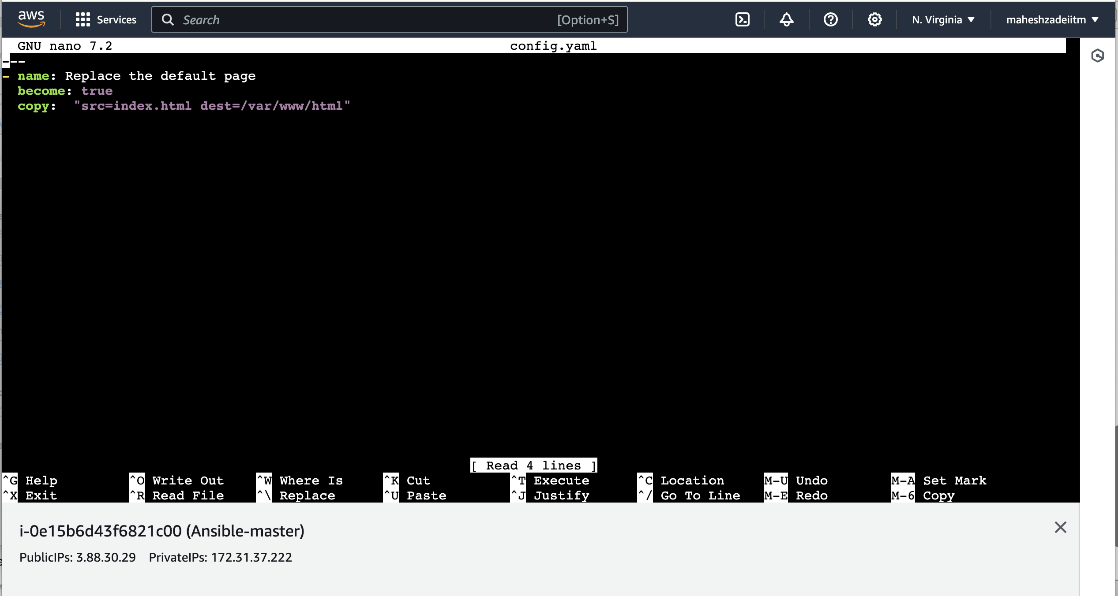

Add config.yaml to main.yml

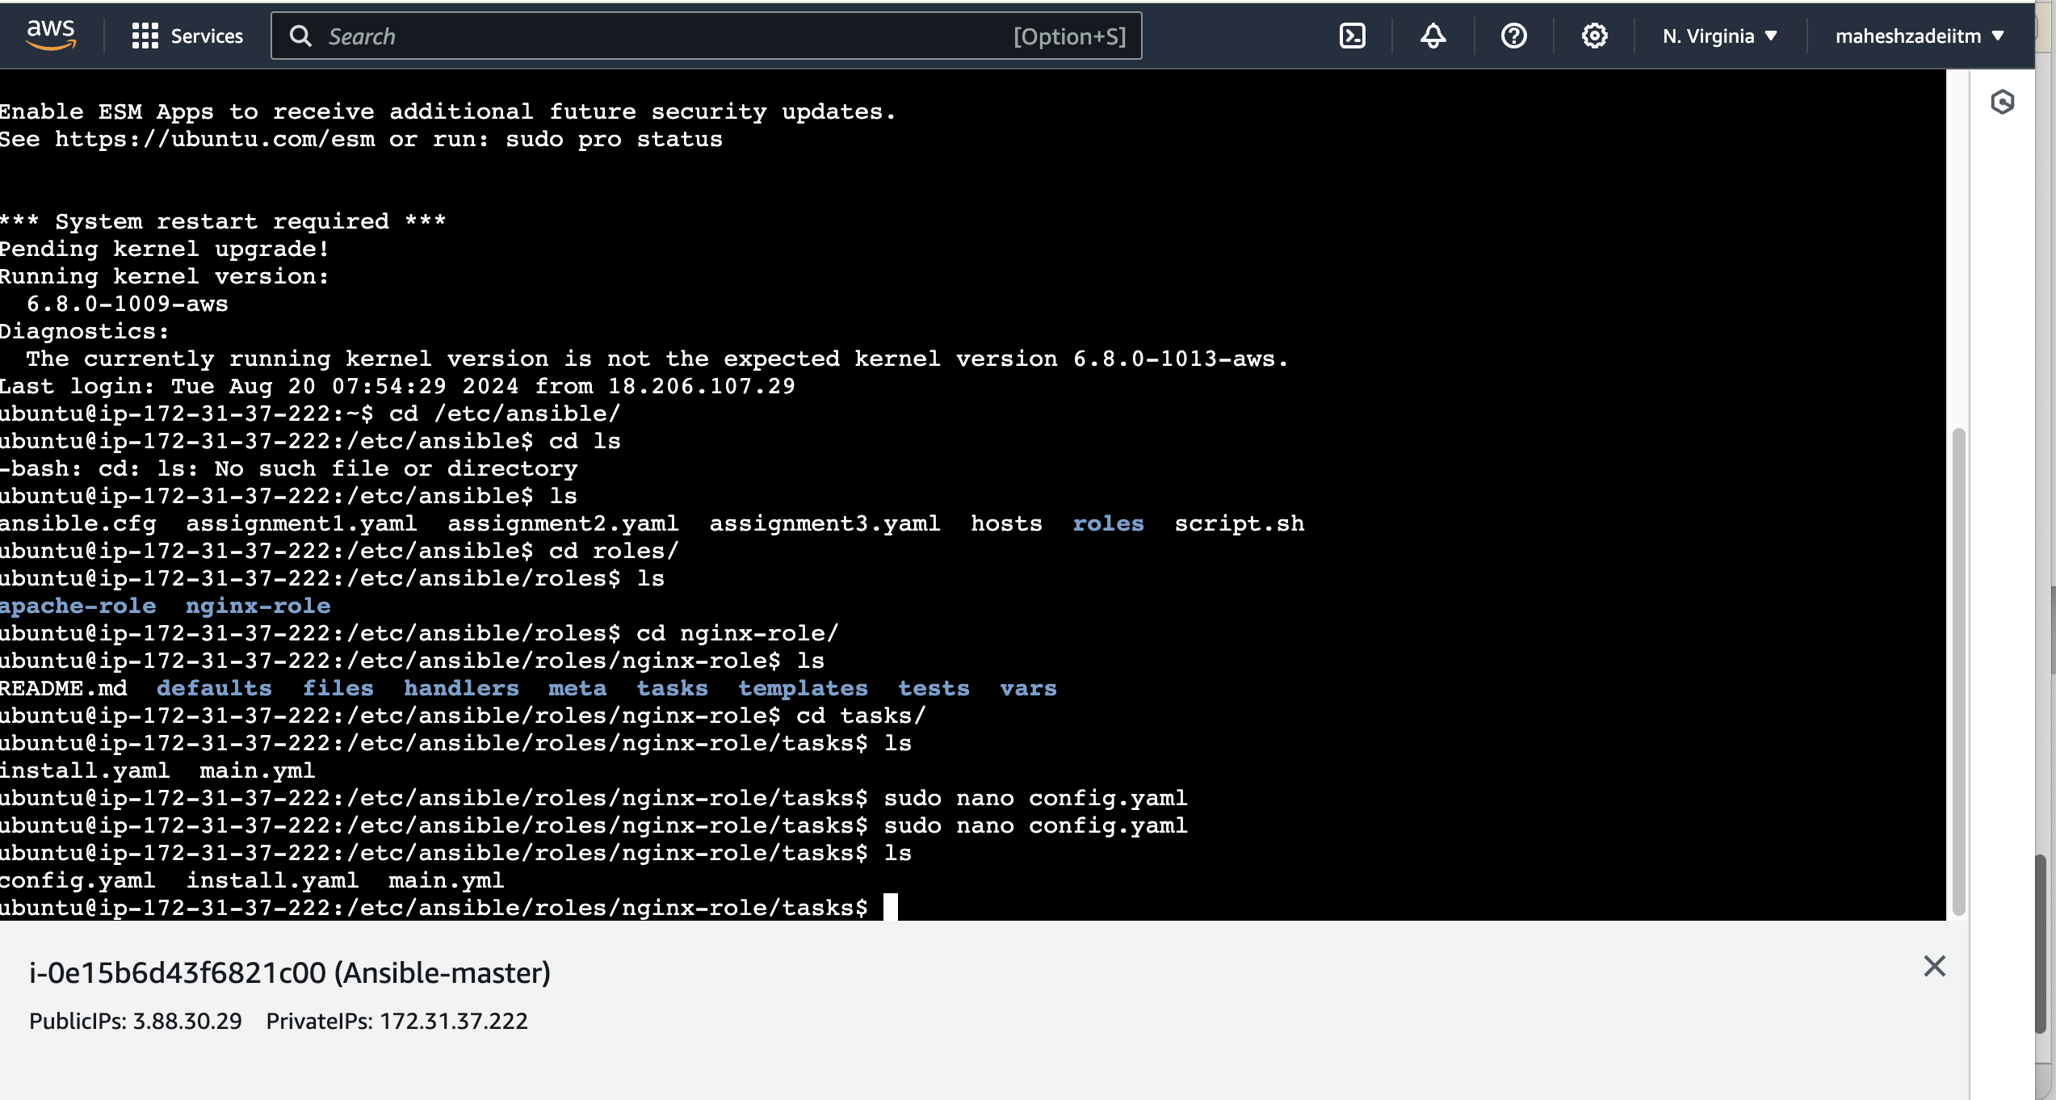

Config.yaml included

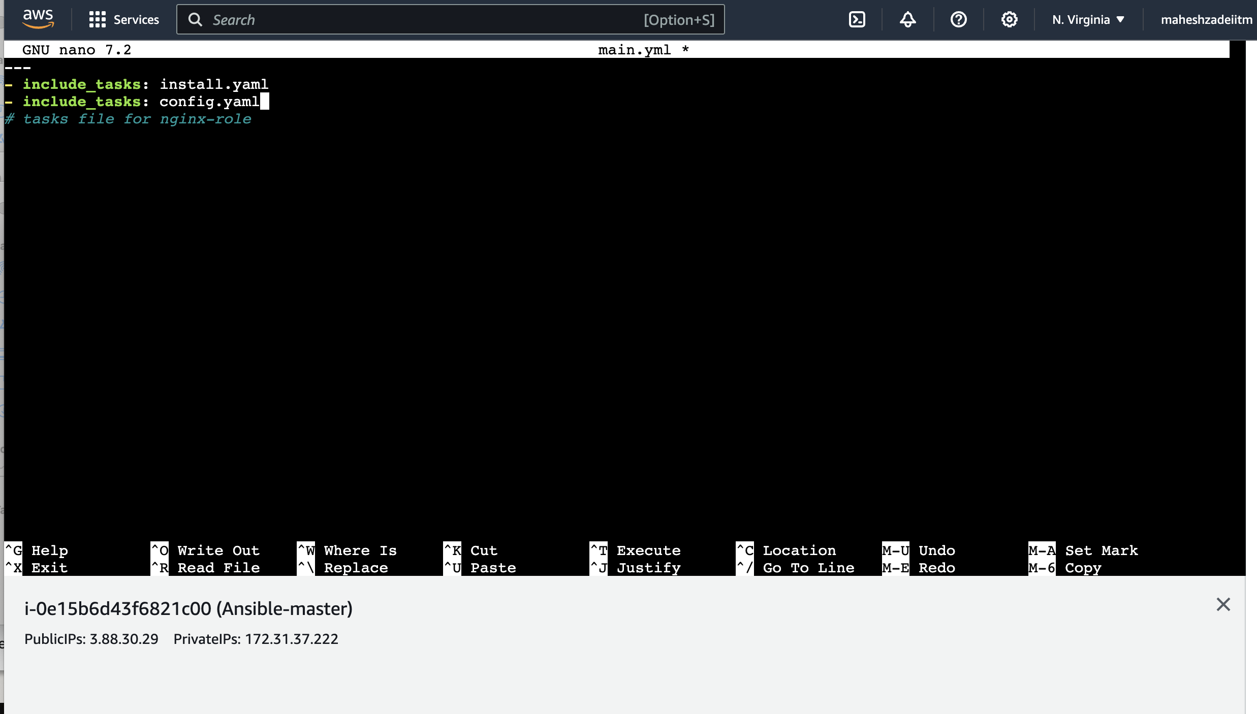

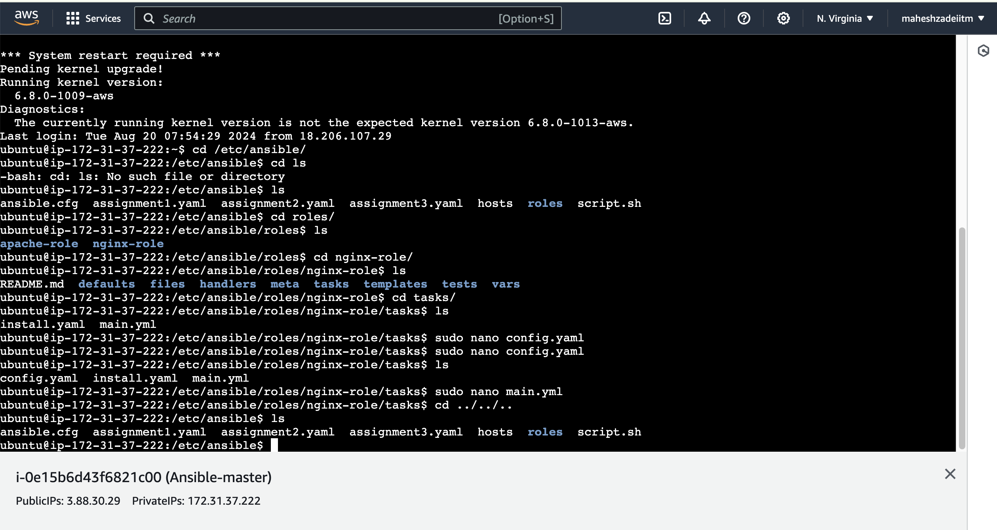

Re-run the assignment3.yaml

Ansible-playbook assignment3.yaml

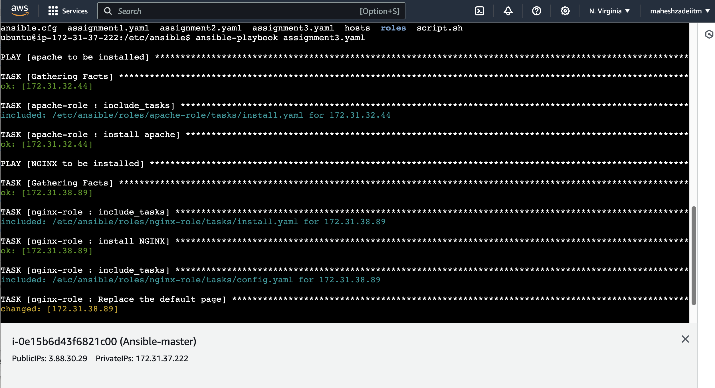

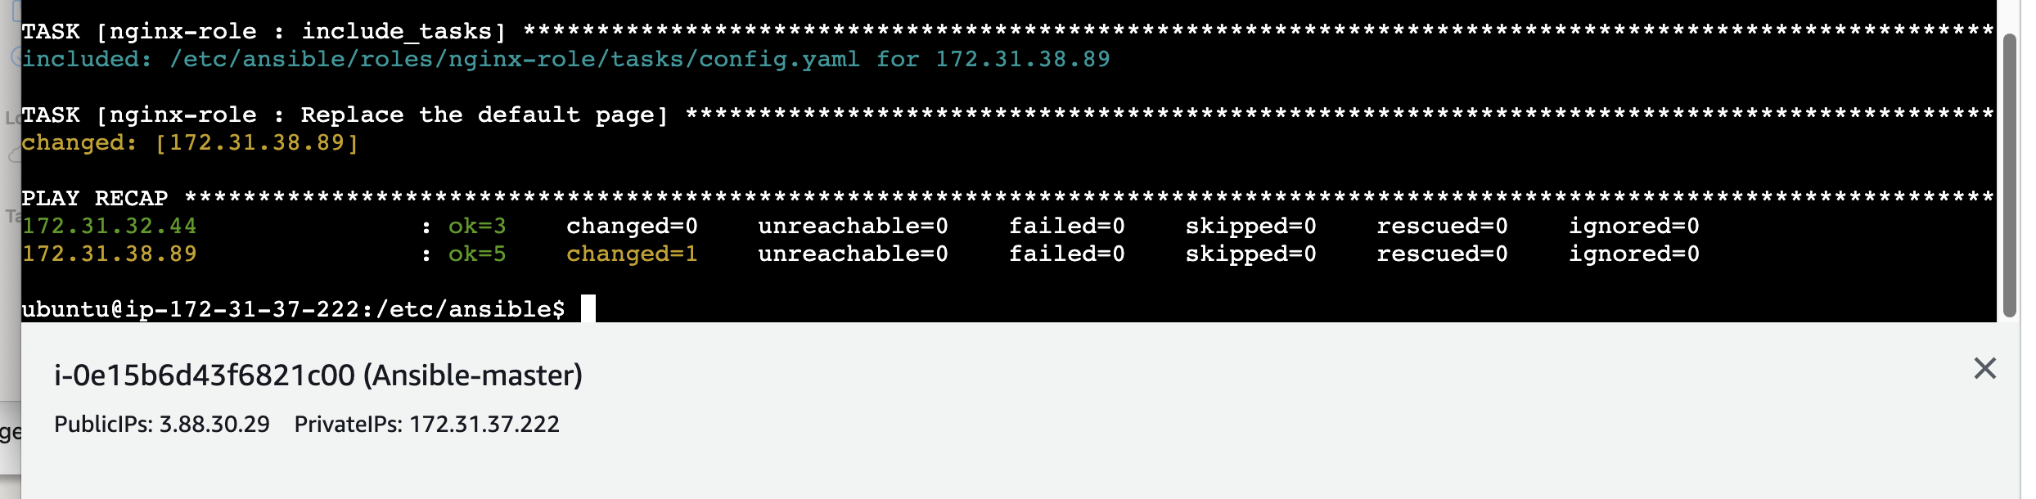

Now check the nginx is working or nor , copy public IP of Slave2 Ec2 machine in browser

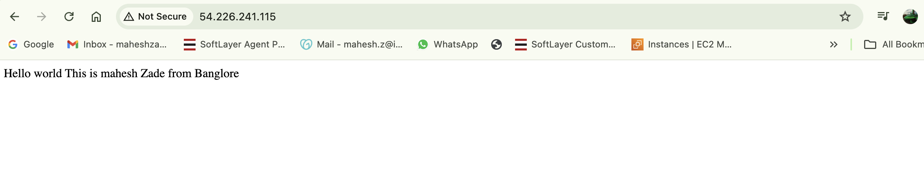

It working fine

Assignment 3 is successful.

Thanks